IAM TASKS

1 Create one IAM user and assign ec2, s3 full access role.  
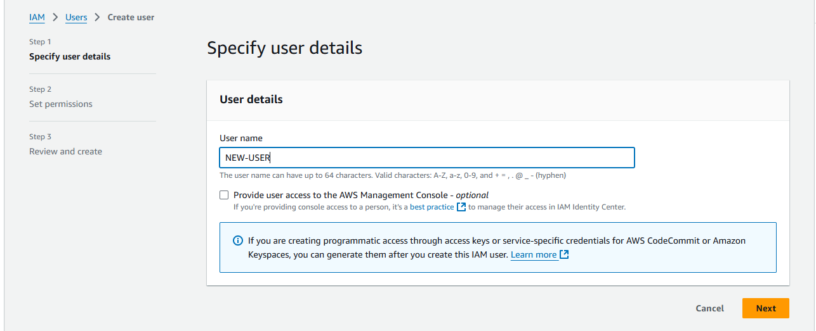

assigning ec2,s3 full access role  
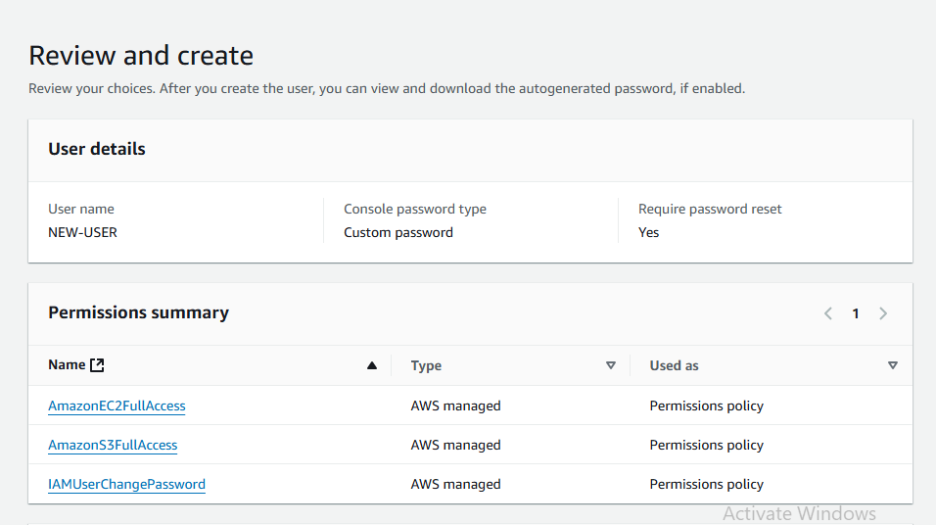

User created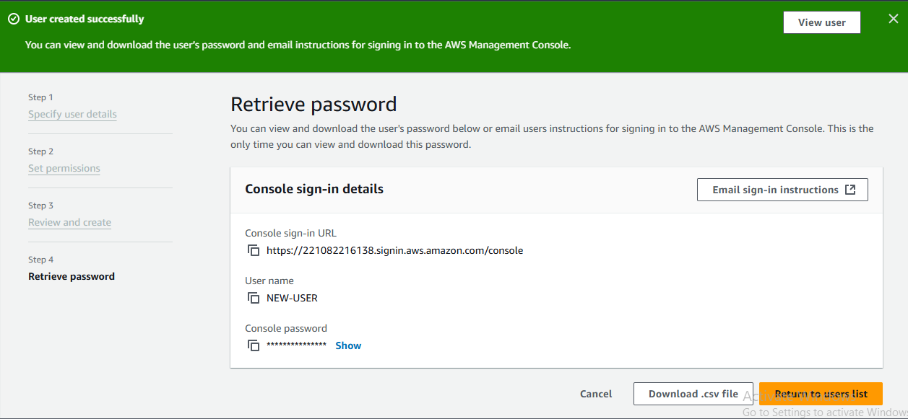

2 Create one Group in IAM and Assign Read access for ec2.

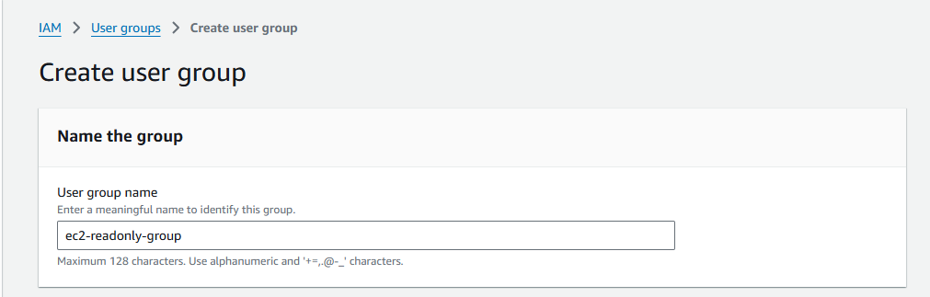  
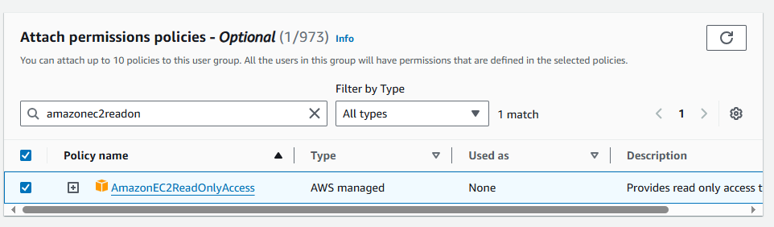

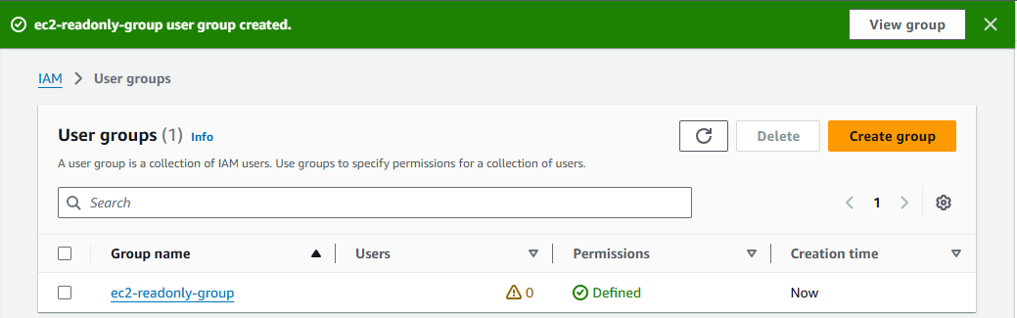

3) Create a new user with name Devops and add to the group created in task2.  
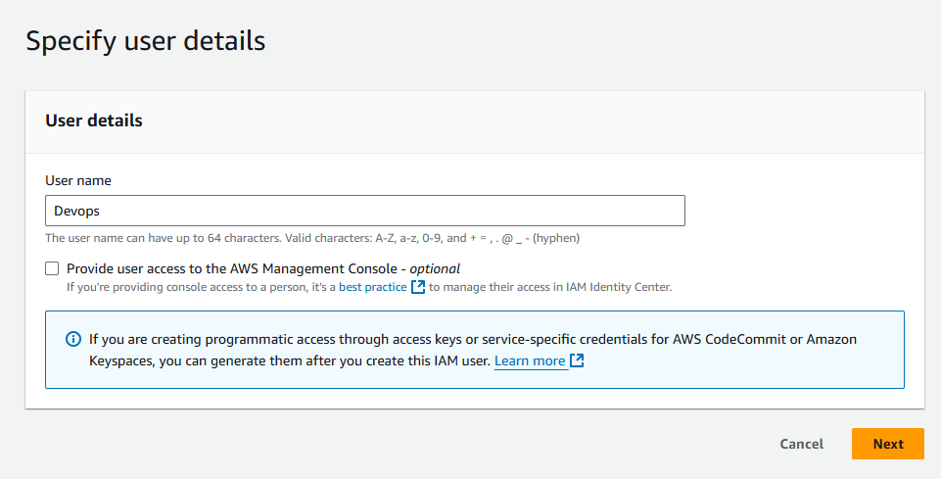

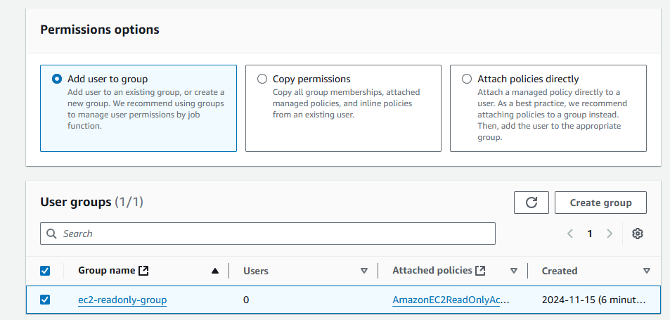  
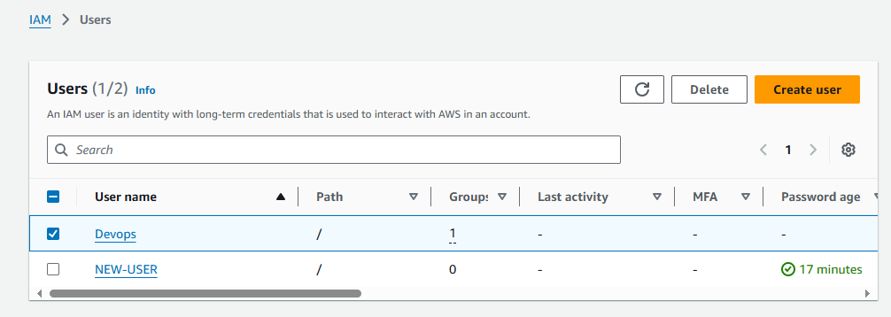

4) Write a bash script to create a IAM user with VPC full access  
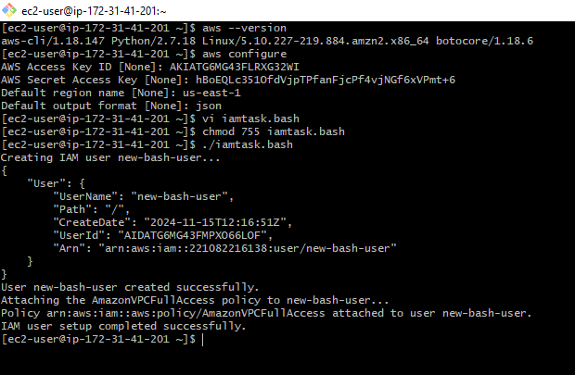

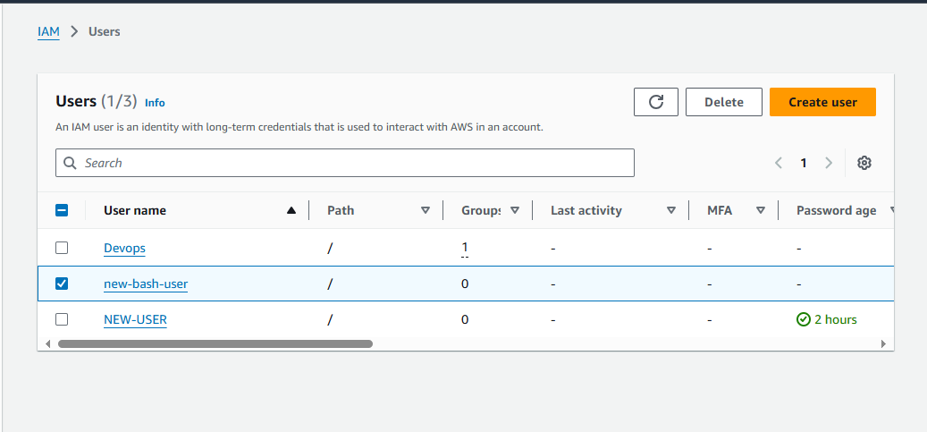

5) Create a IAM policy to access ec2 for a specific user in specific regions only.  
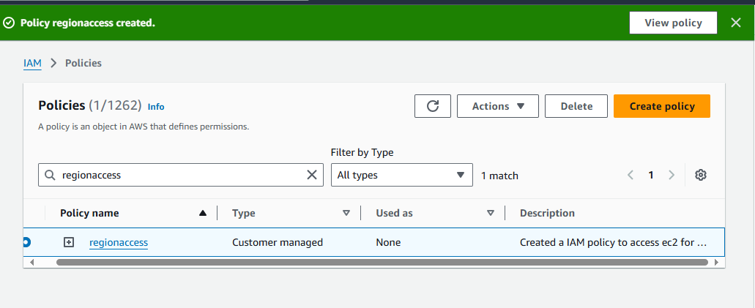  
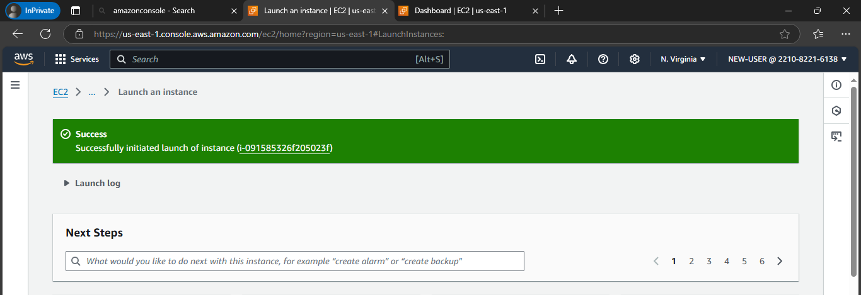

6) We have two accounts Account A and Account B, Account A user should access s3 bucket in Account B.